**LSMDATA-894 - Warehouse Claims Fields to be added from RADM View to Warehouse Claims table**

**IDS Mart - UNIT Test**

Objects changed in this task:

Staging_Genius

dbo/Tables/CBIClaimListing.sql

ODS_Genius

dbo/Tables/CBIClaimListing

dbo/Tables/Map_GeniusClaimHeader

dbo/Views/Map_GeniusClaimHeader_build

dbo/Views/Warehouse_ClaimDetails

dbo/Views/Warehouse_ClaimDetails_Delta

Warehouse_Repository

dbo/Tables/ClaimDetails

ids_mart/Views/Build_Claims

IDS_Mart

dbo/Tables/Claims

1. Loading staging table - [Staging_Genius].[dbo].[CBIClaimListing]

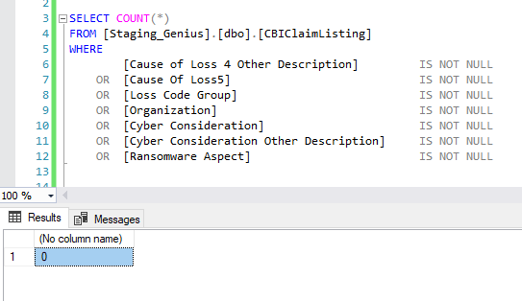

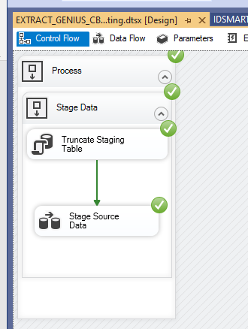

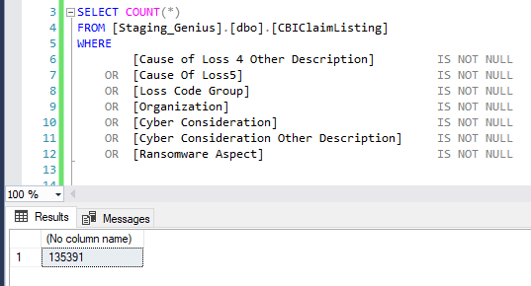

**Status:** Passed

1. Loading empty ODS table - [ODS_Genius].[dbo].[CBIClaimListing]

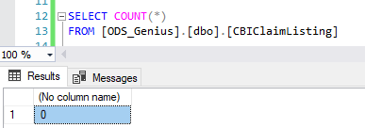

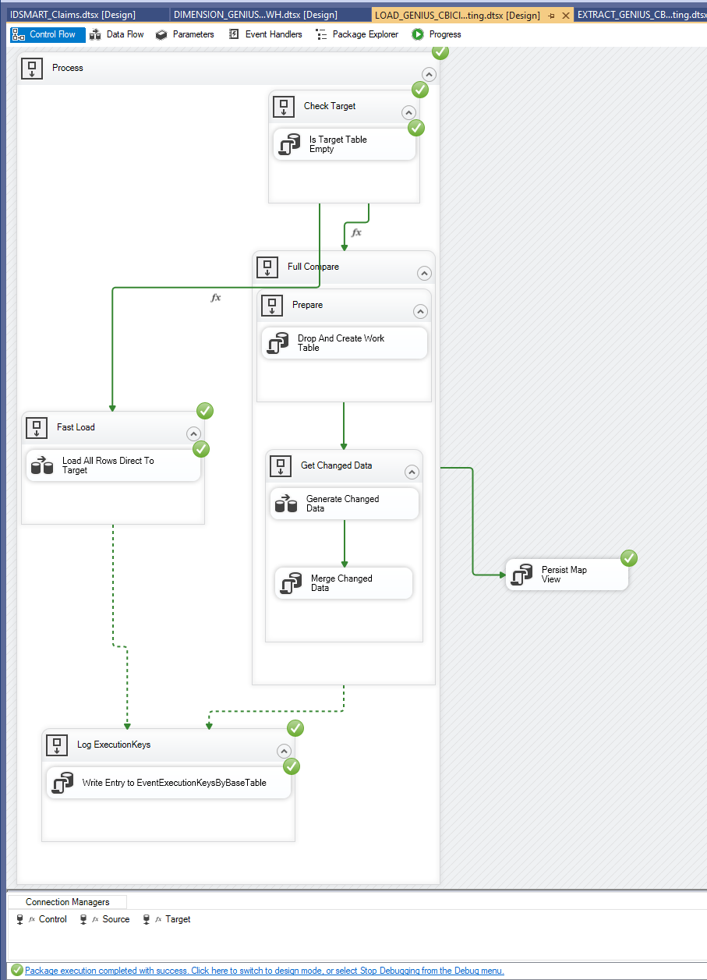

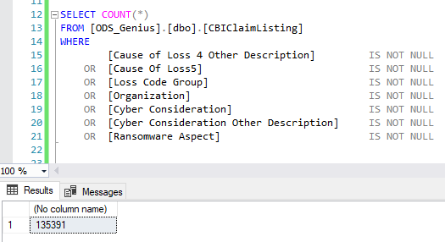

**Status:** Passed

1. Updating, inserting and deleting rows in non-empty ODS table - [ODS_Genius].[dbo].[CBIClaimListing]

Original rows in the table:

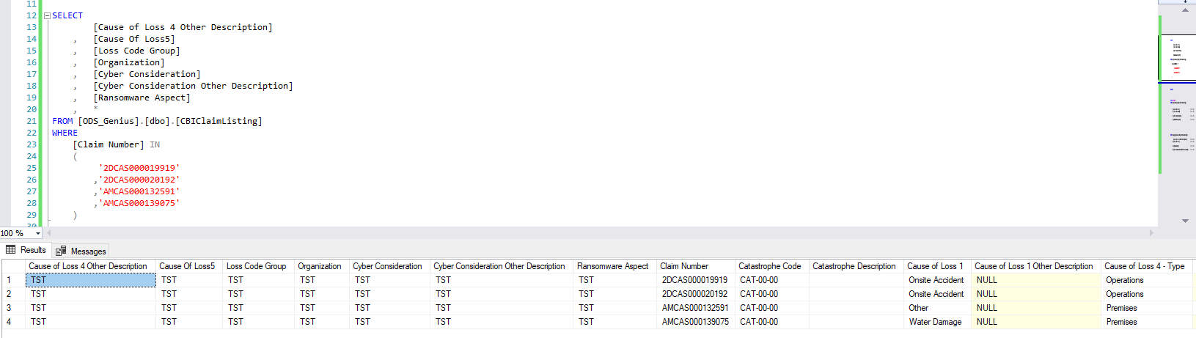

Modified rows for test purposes:

* Deleted row (insertion test) ([Claim Number]= “2DCAS000019919” )
* Updated rows (updating test) ([Claim Number]= “2DCAS000020192” )
* Row deleted in source (deletion test) ([Claim Number]= “AMCAS000132591” )

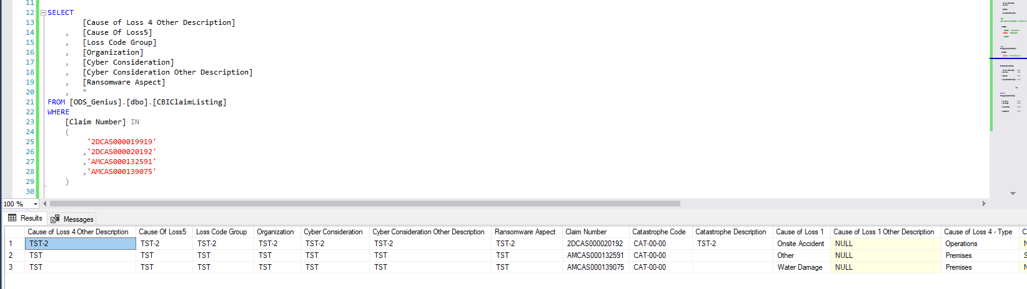

Package execution:

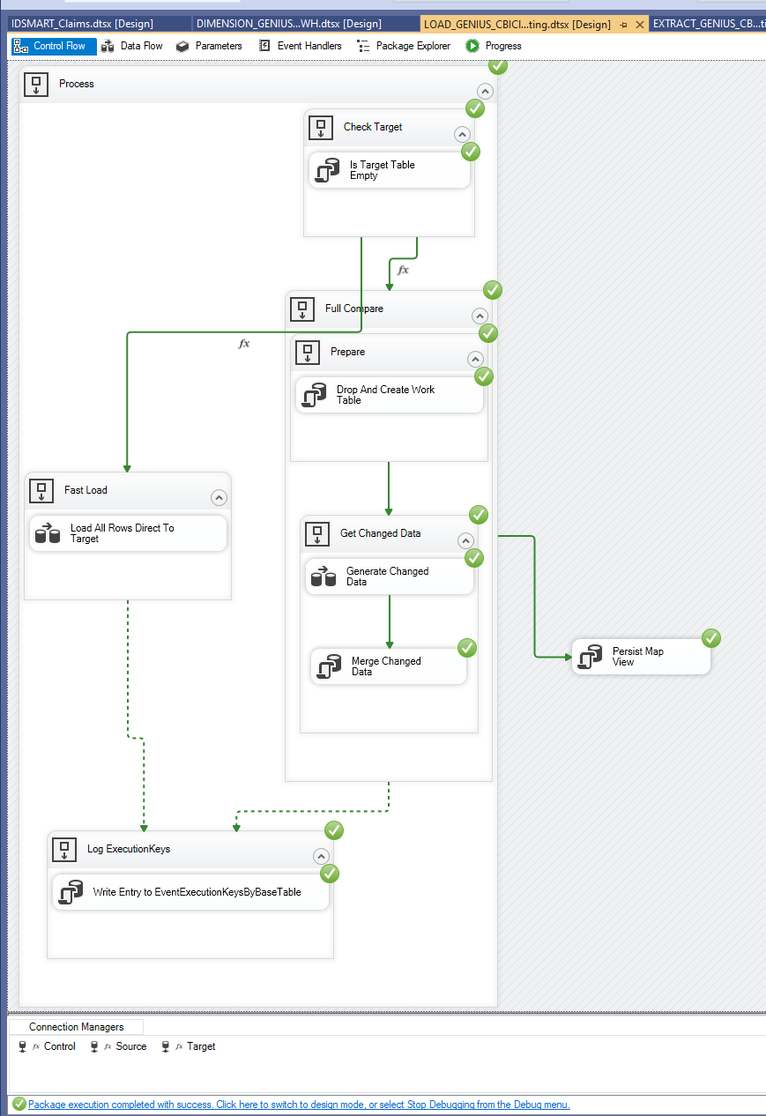

Rows updated/inserted/deleted properly:

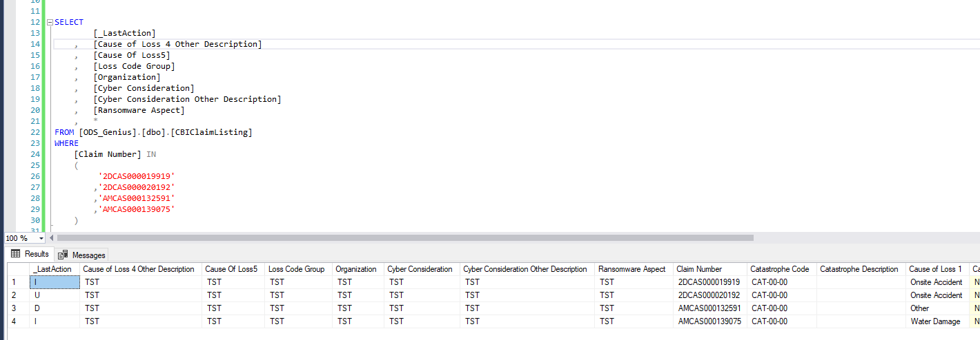

**Status:** Passed

1. Loading Persist Map View table (truncate and insert) - [ODS_Genius].[dbo].[Map_GeniusClaimHeader]



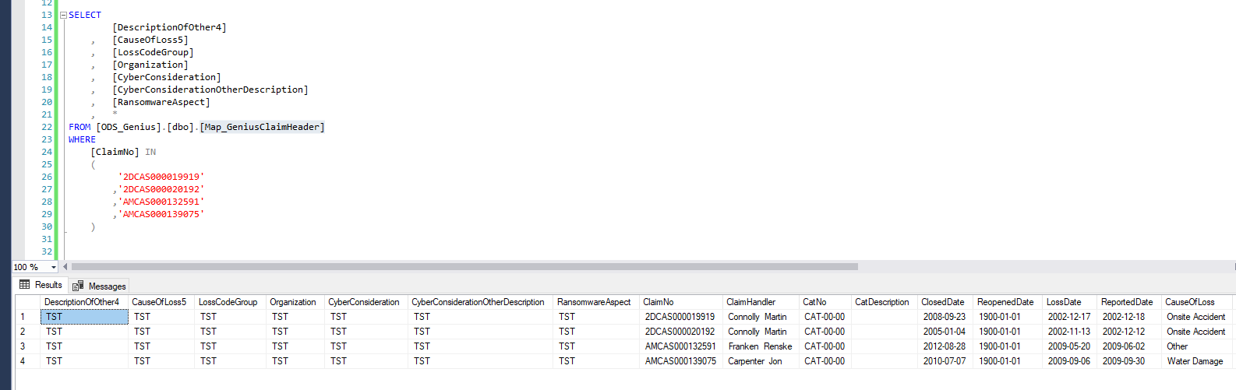

**Status:** Passed

1. Loading empty WR table - [Warehouse_Repository].[dbo].[ClaimDetails]

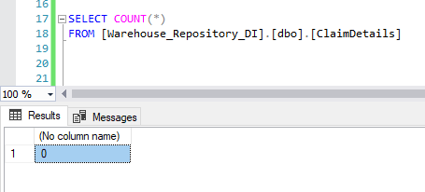

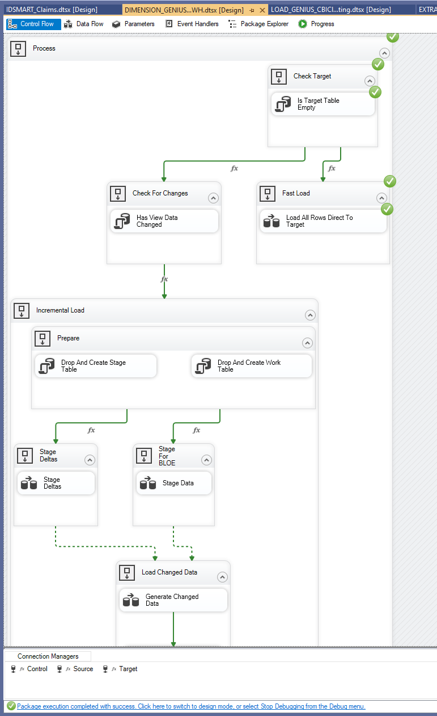

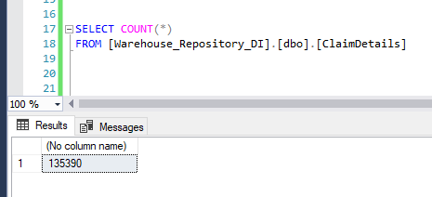

**Status:** Passed

1. Updating, inserting and deleting rows in non-empty WR table - [Warehouse_Repository].[dbo].[ClaimDetails]

Original rows in the table:

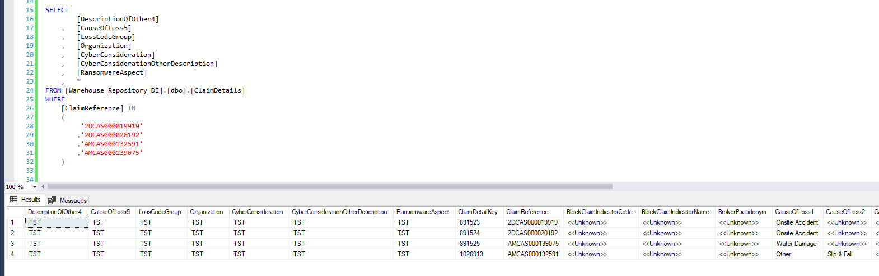

Modified rows for test purposes:

* Deleted row (insertion test) ([ClaimReference]= “2DCAS000019919” )
* Updated rows (updating test) ([ClaimReference]= “2DCAS000020192” )
* Row deleted in source (deletion test) ([ClaimReference]= “AMCAS000132591” )

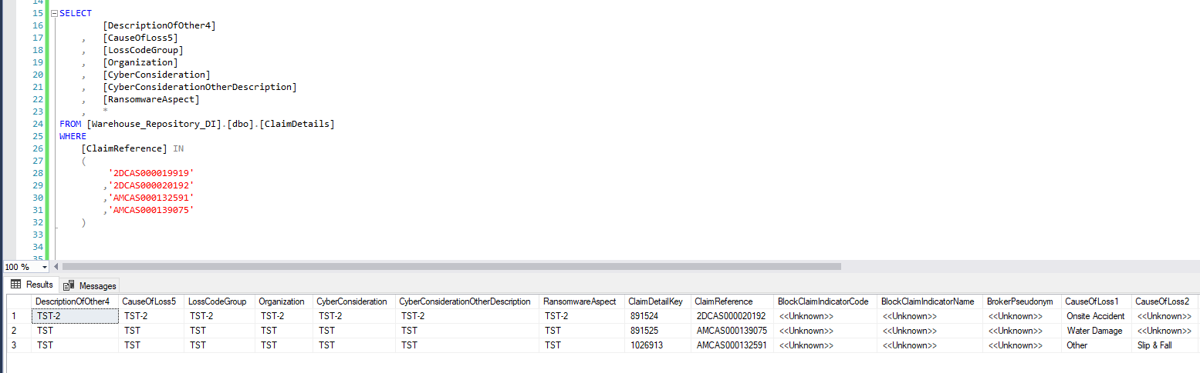

Package execution:

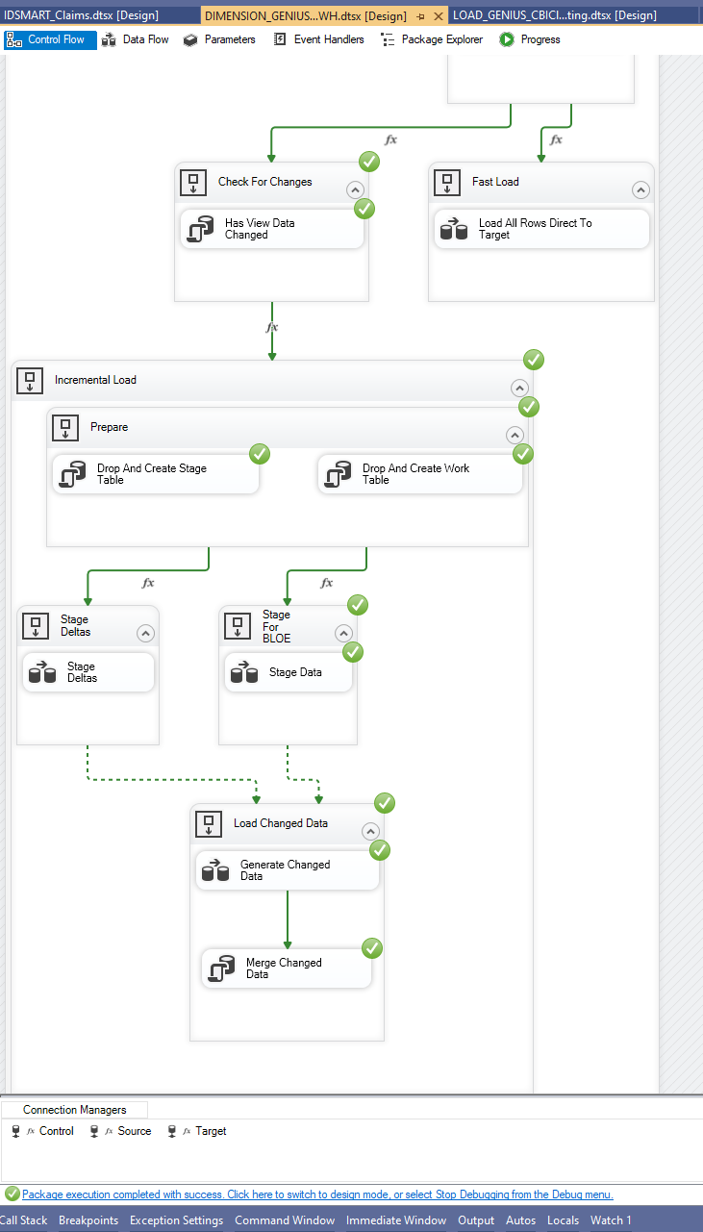

Rows updated/inserted/deleted properly:

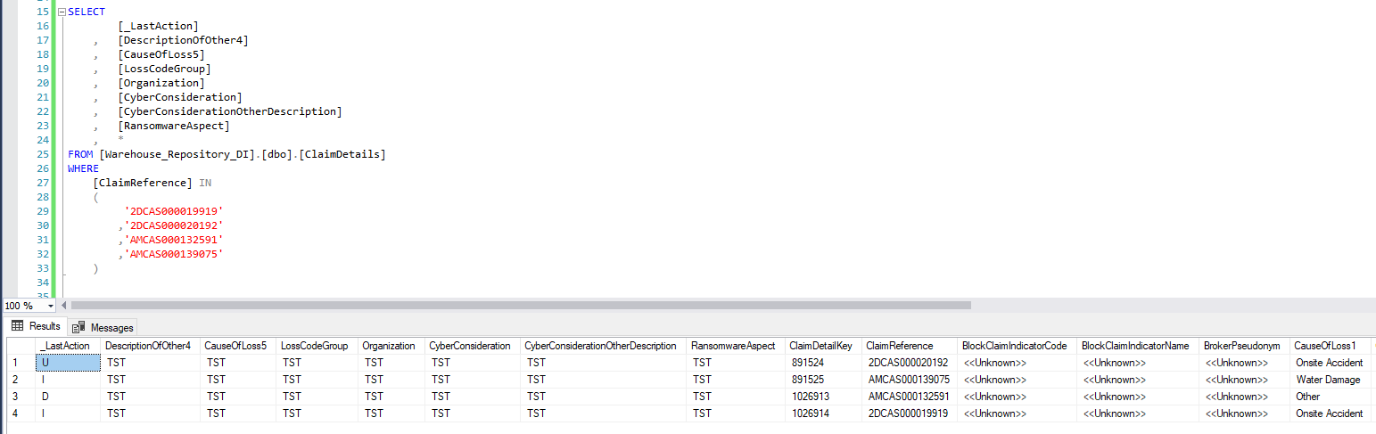

**Status:** Passed

1. Loading IDS_Mart table - [IDS_Mart].[dbo].[Claims]

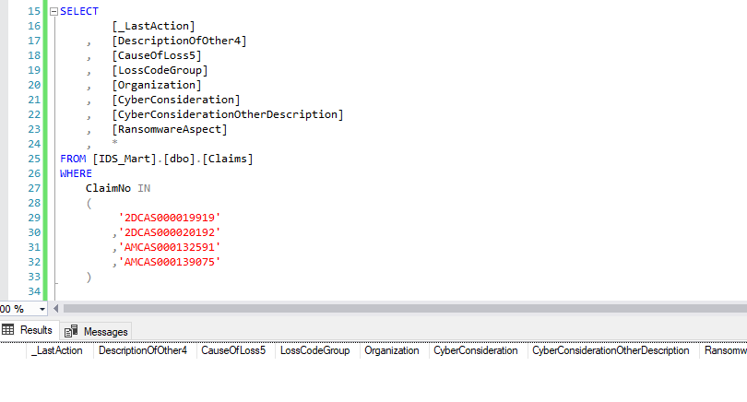

**Status:** Passed